Unit 2 test
Vocabulary
Vocabulary
1 Look, read and tick ().
1 cereal
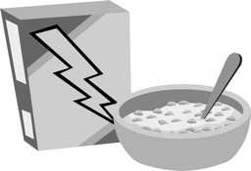 |  | 
A ☐ | B ☐ | C ☐
2 meatballs
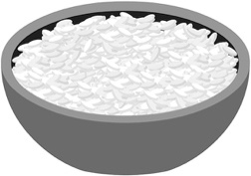 |  | 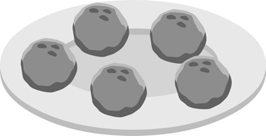
A ☐ | B ☐ | C ☐
3 yoghurt
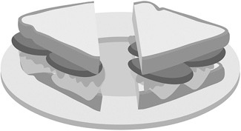 |  | 
A ☐ | B ☐ | C ☐
/ 3
2 Look, read and circle.
 |  |  |  | 1 potatoes / beans  2 cucumbers / carrots  3 peppers / beans  4 cucumbers / peas  5 carrots / potatoes  6 peas / peppers
1 | 2 | 3
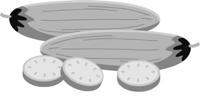 |  | 
4 | 5 | 6
/ 6
Grammar
3 Look, read and write do, don’t, does or doesn’t.
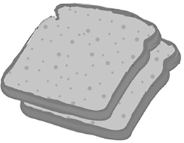 | 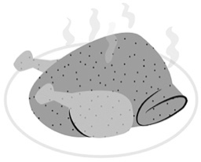 | 
1 Does she have bread  for breakfast?  Yes, she . | 2 Do you have biscuits  for dinner, Dev?  No, I . | 3 Does she have  cereal for lunch?  No, she .
 | 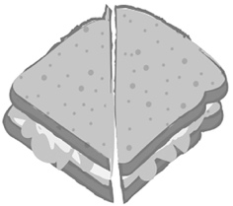 | 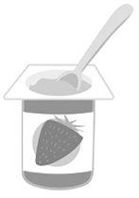
4 Does he have chips  for dinner?  Yes, he . | 5 Do you have a sandwich for lunch?  Yes, I . | 6 Does he have eggs  for breakfast?  No, he .
/ 6
4 Read and tick ().
1 Does she like peppers? Yes, she … .
A ☐ doesn’t B ☐ does
2 … you like carrots? No, I don’t.
A ☐ Doesn’t B ☐ Do
3 Does he like cucumbers? No, he … .
A ☐ don’t B ☐ doesn’t
4 Do you like beans? Yes, I … .
A ☐ do B ☐ does
5 … he like potatoes? Yes, he does.
A ☐ Does B ☐ Doesn’t
/ 5
Reading
5 Read and tick ().
Home About me
I’m Soto. I’m from Greece. I have lunch at home every day. Mum’s got hot food. We’ve got gemista! Yummy! It’s Greek food. Gemista is my favourite food.
It’s peppers and rice. We have it on Tuesdays. We’ve got chips for lunch, too.
I like chips! Do you like chips? Mum’s got yoghurt and apples, too. I like yoghurt.
I don’t like apples. I have a drink, too. Orange juice … yum!
1 Soto …
A ☐ has lunch at home. B ☐ doesn’t have lunch at home.
2 Soto has …
A ☐ a cold lunch today. B ☐ a hot lunch today.
3 Gemista is peppers …
A ☐ and chips. B ☐ and rice.
4 Soto likes …
A ☐ yogurt and apples. B ☐ yoghurt.
5 Soto …
A ☐ has a drink. B ☐ doesn’t have a drink.
/ 5
Writing
6 Read and write.
doesn’t like milk don’t like carrots got cake have got peas likes beans
1 I have got beans and I .
2 He likes chicken and he .
3 She doesn’t like juice and she .
4 I’ve got biscuits and I’ve .
5 I don’t like peppers and I .
/ 5

Listening
7  2 What foods does Sophia like? Listen and circle the tick () or the cross ().
 | 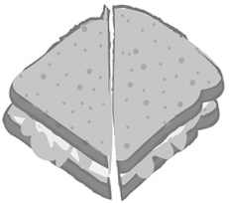 | 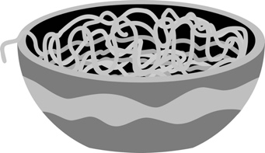
1 / | 2 / | 3 /
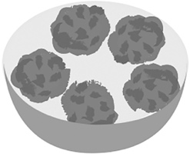 | 
4 / | 5 /
/ 5
Speaking
8 Look, read and answer.
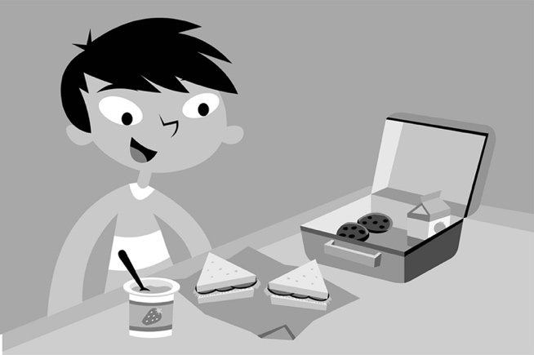
1 Does Hiro have yoghurt for lunch?
2 Does he have chicken and peas for lunch?
3 Does he have chips for lunch?
4 Does he have sandwiches for lunch?
5 Does he like sandwiches?
/ 5
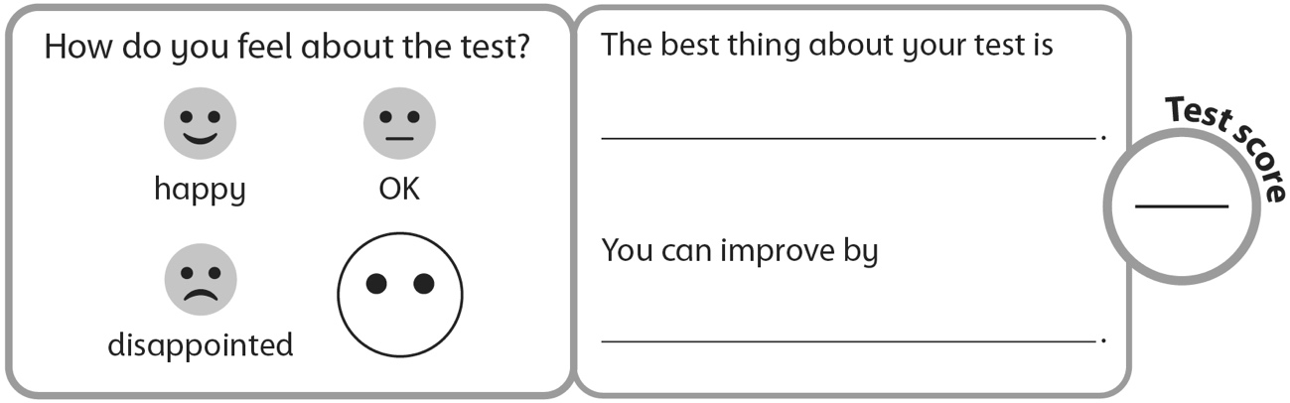
40

